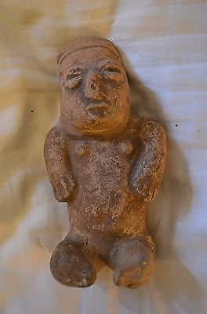

#### [Mayan Seated Figure - 300 B.C. - 300 A.D. - Fertility Theme, Pre-Columbian](http://www.ebay.com/itm/151878374928)

|  |  |
| --- | --- |
| Item price | $65.00 |
| Quantity | 1 |
| Item number | 151878374928 |
| Shipping service | USPS Priority Mail |

## Sales order

Sold by [acuervo22](http://myworld.ebay.com/acuervo22) ( [223](http://feedback.ebay.com/ws/eBayISAPI.dll?ViewFeedback&userid=acuervo22) )

### Delivery package 1 of 1

Estimated delivery Wednesday, Nov 18, 2015